Lliwiau – Teacher’s Notes

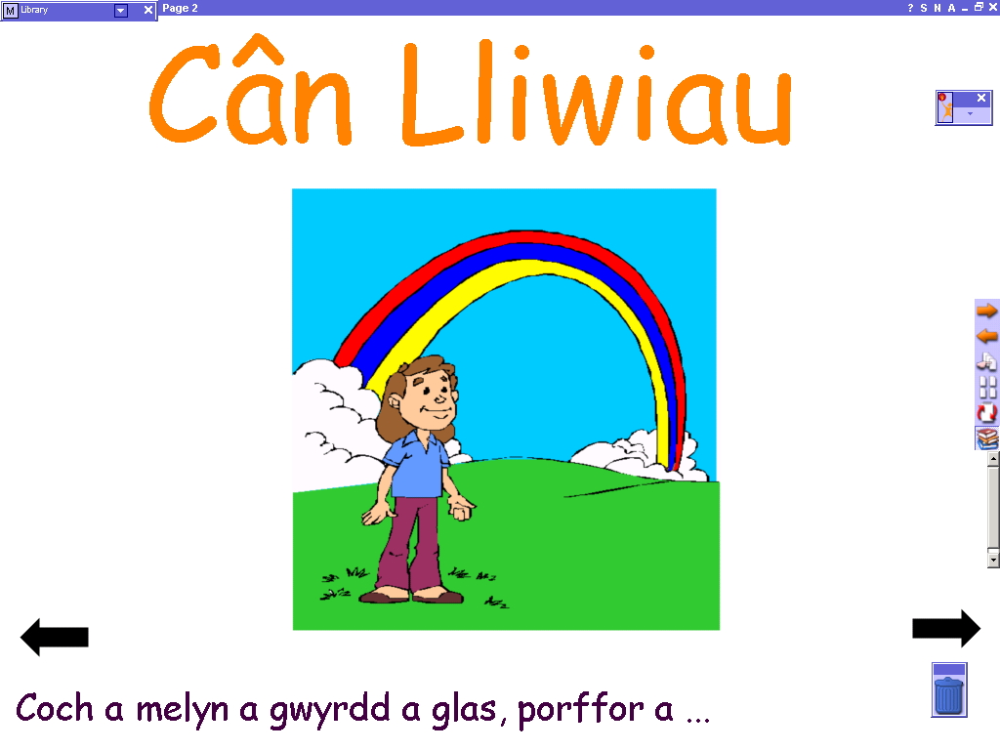
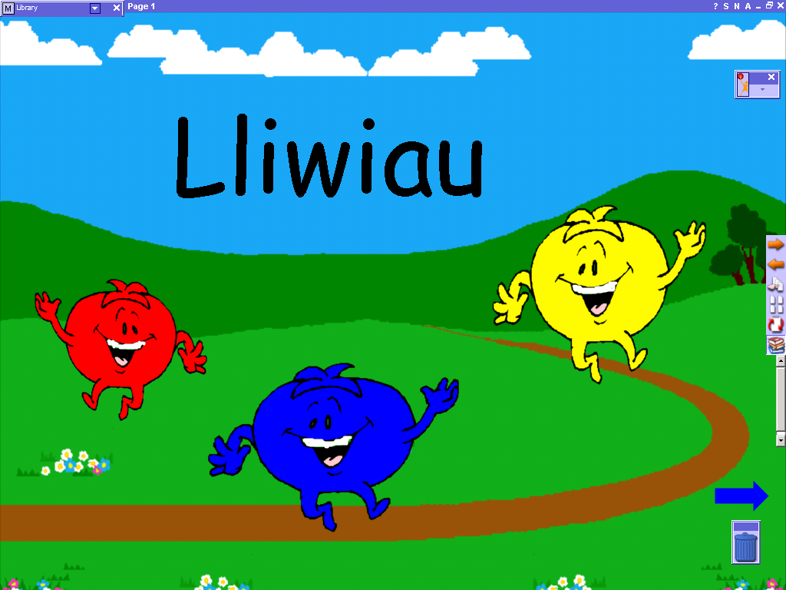
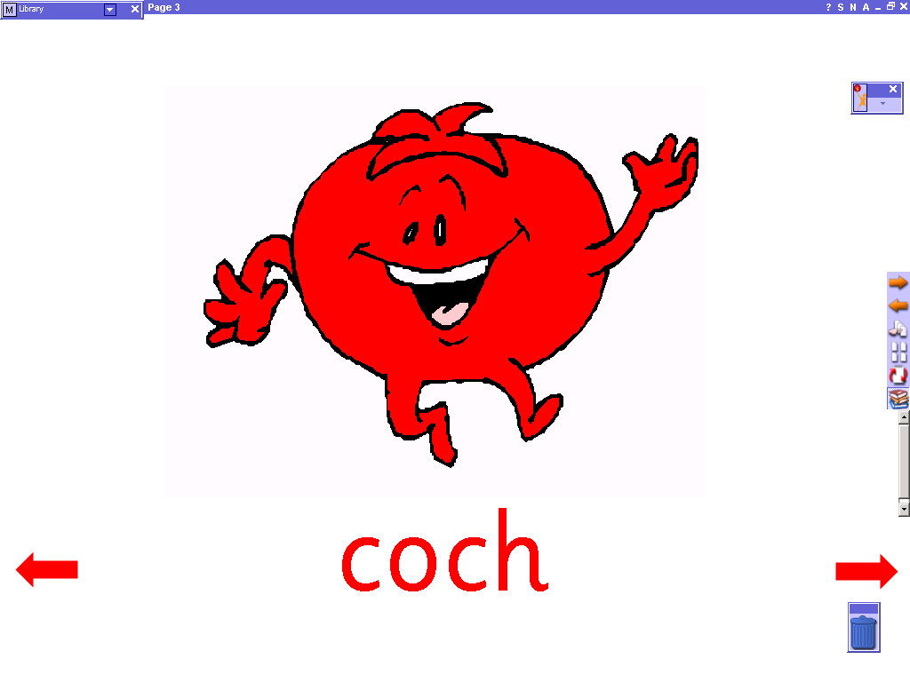
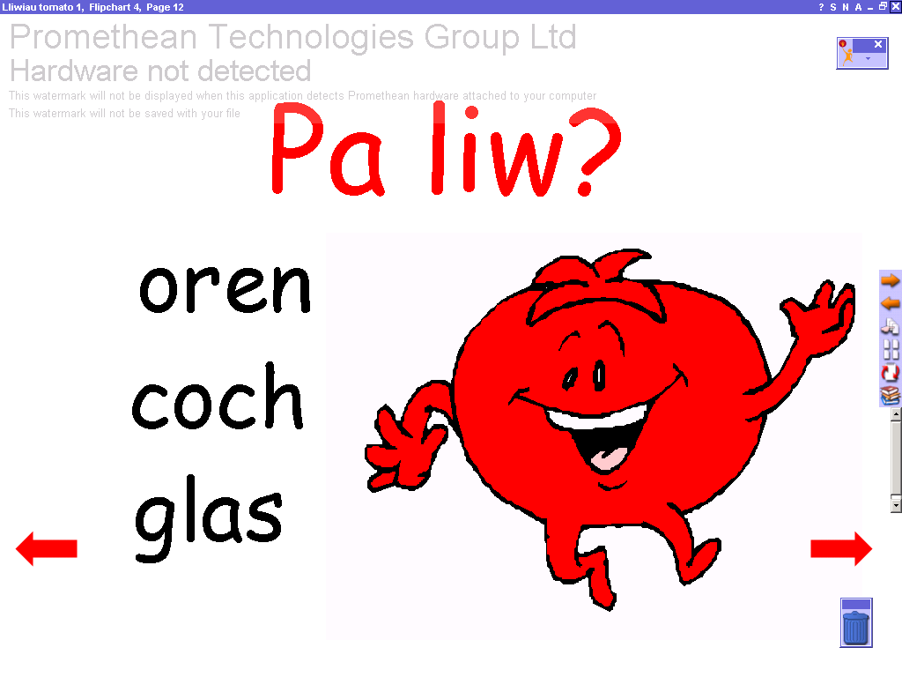
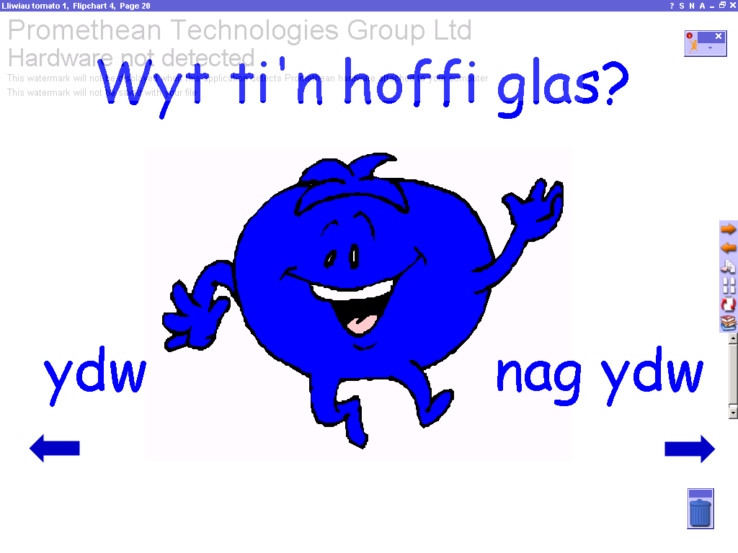
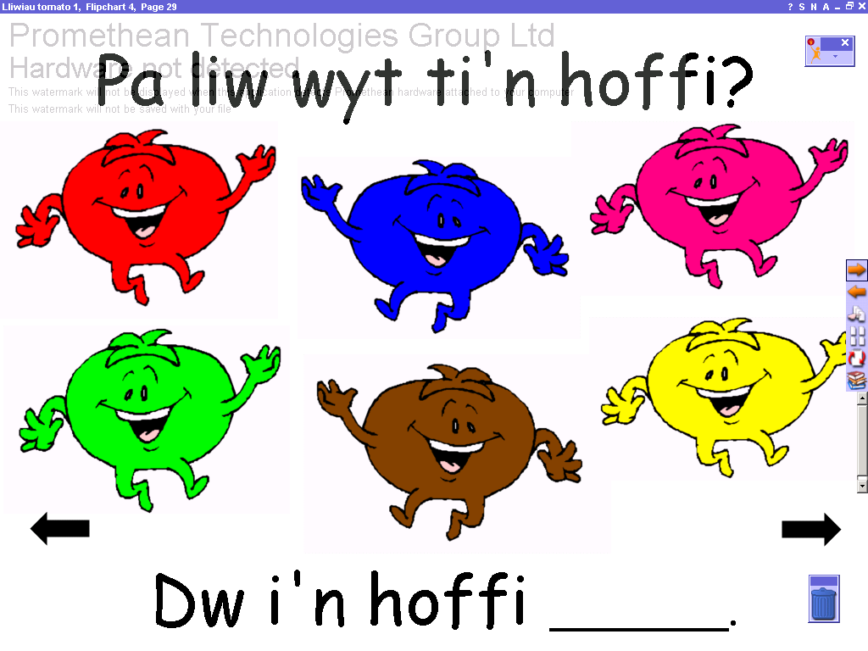

Start page.
Click on the arrows to move forwards and back.

Click on the picture to hear the song – Lliwiau’r Enfys. (Rainbow Colours)
Words shown at bottom of page.

Pages 4 - 11 introduce the colours.
Coch, glas, gwyrdd, melyn, oren, brown, pinc, porffor.
(Red, blue, green, yellow, orange, brown, pink, purple.)

Pages 12 – 18 introduce question ‘Pa liw?’ (Which colour?)
Click on the correct answer. An incorrect answer gives an opportunity to try again. Click in the face to return to the flipchart.

Pages 19 – 26 introduce question ‘Wyt ti’n hoffi ___?
(Do you like ___?)

Pages 27 – 29 introduce question ‘Pa liw wyt ti’n hoffi?
(What colour do you like?)

